**LAUNCHPAD 95**

**Introduction**

The Launchpad 95 is an Ableton Live Control Surface interface designed to enrich the functionality of the Novation Launchpad MIDI controller. It does not require any external tool like Max for Live (M4L) in order to work. This script is just a plain Live Control Surface Python Script. The following pages will show you where all the buttons and pads are and how they function, as well as tips and tricks that we have found to be effective.

**The Launchpad Overview**

The following diagram shows the top of the Launchpad, which has four main areas:

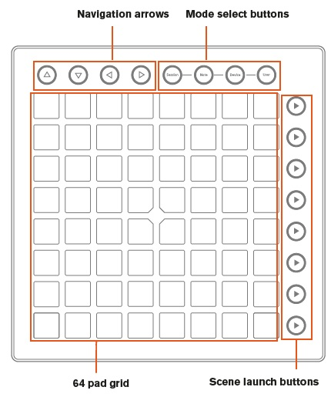

The above areas work together for a fun and creative musical experience, as explained throughout this guide.

With an understanding of where things lie on the Launchpad, it’s time to learn how to use it.

**Installation**

Follow these steps to install the Launchpad95 script

First, download the installation archive:  
- live 9.2.+ : [**Launchpad95.zip**](http://motscousus.com/stuff/2011-07_Novation_Launchpad_Ableton_Live_Scripts/Launchpad95.zip)  
  
Unzip the zip file and copy the folder Launchpad95 into the Ableton Live's "MIDI Remote Scripts" folder.

On pc/windows 7 : inside "C:\ProgramData\Ableton\Live 9 Suite\Resources\MIDI Remote Scripts"  
On a mac right-click the Live application you use (there might more than one installed!) and select "view package content", then browse to "App-Resources/MIDI Remote Scripts".   
  
Inside this "MIDI Remote Scripts" folder, you should have a folder called "Launchpad95". inside this folder you should have a bunch of .py files, and a for each of them a .pyc file. (.pyc files are compiled version of the .py that live compiles as you start it.)  
  
Sometimes a picture is worth 1000 words. Take a look at these screenshots.

On a mac it looks like this: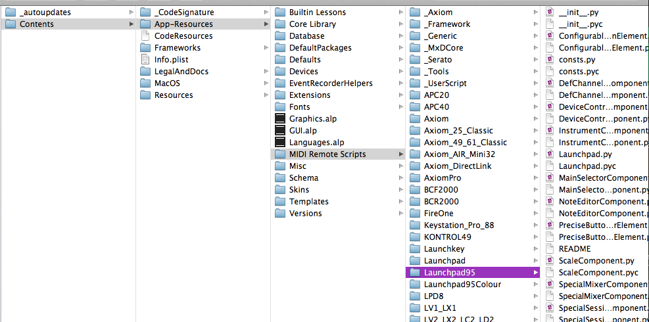  
On a pc like this: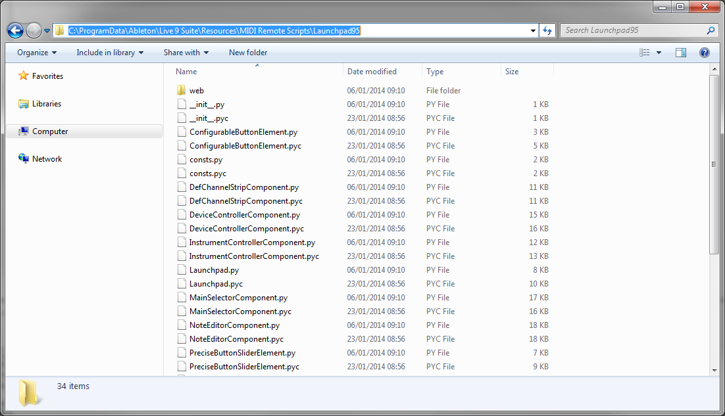

Once the folder has been copied, plug-in your Launchpad in the computer and start Ableton Live.

Open up the preferences panel and go to "MIDI Sync" panel.

Select Launchpad95 as your control surface, and Launchpad as Input and Output ports:

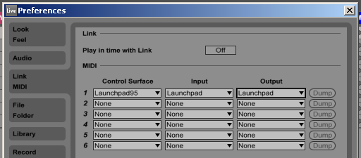

Also select the Launchpad Midi Port midi ports like so :



Track On sets the Launchpad as an Input device to play MIDI tracks (instruments and drums) in Live, and as and Output device to see played and recorded notes feedback to the pad LEDs.

Remote On for both Input and Output allows the Launchpad to be manually mapped to parameters in Live, and to see feedback of that mapping.

If you find that features described later in this user guide are not working as expected, please re-check your MIDI port settings

**Button behavior**

Two important behaviors to keep in mind as you learn about the Launchpad (the Mode Select and Mixer buttons in particular) are what we’ll refer to as ‘latch’ and ‘momentary’. Understanding these two behaviors will help you quickly move around the Launchpad during live performance. Fortunately, the difference between latch and momentary is simple:

• **Latch** means that when a button (e.g., Session) is pressed and quickly released, the functions are available until the user navigates away (i.e., hits another button). Latch is best used when spending an indefinite time with Mode or Mixer parameters.

**Latch mode behavior is similar to a Capslock key behavior on a computer keyboard**

• **Momentary** describes the temporary access of Mode or Mixer functions. Press and hold a button (e.g., Scale), make adjustments with the RGB pads, then upon release of the button you will jump back to what you were previously viewing (e.g., User1). In other words, functionality is available as long as you hold the button. Momentary behavior is great when performing and time is limited.

**Momentary behavior is similar to the Shift key behavior on a computer keyboard.**

It is also important to note that some buttons that there are a few more modes to use a button in order to expand the possibilities of the Lauchpad functionality:

For some buttons, you will get different results if you press and release a button, if you keep it pressed for more than half a second or if you keep it pressed for more than 2 seconds.

You can also access different functions by double clicking a button.

All the buttons functionality will be described in the following chapters

**Using the Launchpad95**

There are 9 available modes in the script (some of them are the original Launchpad mode and some of them are new ones):

* **Session**: useful to control clip and scene playback (plain old “frame” behavior)
* **Zoom**: useful for navigating through a large number of scenes and tracks
* **Step Sequencer**: Useful for MIDI sequencing percussive and melodic ideas
* **Vintage Step Sequencer**: Useful for sequencing in the old fashioned way.
* **Device Controller**: Useful for control Device parameters
* **Instrument Mode**: Useful to play midi
* **User 1 Mode**: TBD
* **User 2 Mode**: TBD
* **Mixer**: Allow to control mixing and record features (volume, pan, sends, arm, mute, etc.).

Those modes can be selected by using the 4 mode select buttons

**Session and Zoom mode**

The first of the Mode Buttons (upper right-hand corner of the Launchpad) is Session Mode, this mode allow you to select the Session mode and the Zoom mode.

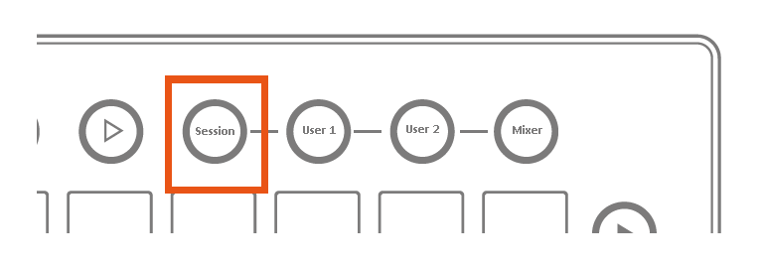

This may be the most important of the four mode buttons; since pressing it lets you physically control Live’s Session View. If you’re new to Ableton Live, the Session View is where you can launch, record or edit audio or MIDI ‘clips’ without ever stopping the music. In other words, this is where you can jam forever.

**The Session mode**

To enter this mode just press the Session Mode Button.

When in Session mode, the Launchpad 8x8 grid of RGB LED pads gives you intuitive visual feedback on your clips as you launch, stop, edit or record them. Conversely, you can see the area covered by these 64 pads on your Live screen inside a colored, 8x8 rectangular ‘ring’ or ‘box’.

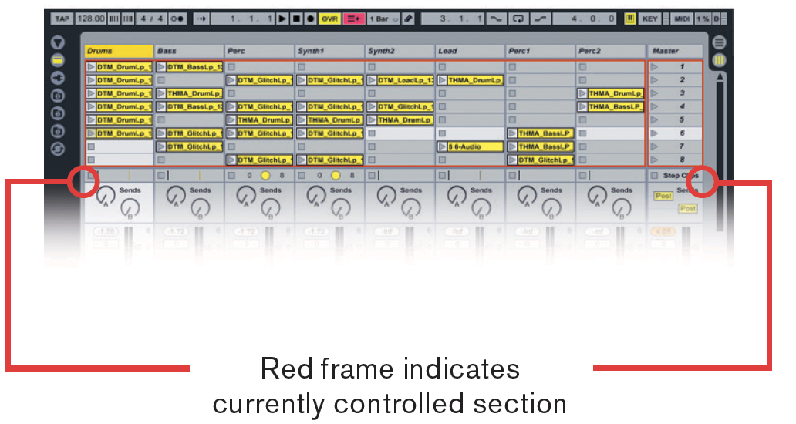

Pressing a clip launch pad triggers the clip in the corresponding clip slot in Live. Hitting an empty clip slot in a track that is not armed will stop the clip playing in this track. If the track is armed to record, pressing the button records a new clip. The navigation arrows and the session button increase the scope of the eight-by-eight grid by navigating the session view in scenes and tracks. You can also fire horizontal lines of clips (scenes) with the buttons on the right hand side of Launchpad.

**Clip Triggering and Colors**

The buttons in the matrix light up in different colors so you know what’s going on:

**AMBER**: this slot contains a clip **GREEN**: this clip is playing **RED**: this clip is recording

Clips that have been triggered, but have not yet started to play, quickly flash green until launched. Empty clip slots in Live show up as unlit pads on the Launchpad. Hitting an unlit pad will either do nothing, or it will stop playing clips on that track. On a record-armed track, empty clips slots are lit dimly red, indicating that they are ready to become new audio or MIDI clips. When triggered, these pads will quickly flash red until they start recording. To stop recording a clip, press its pad again. With recording complete, the pad will turn green.

**QUICK TIP 1**: It might be helpful to think of red pads on armed tracks as ‘hot’, since pushing those starts the recording of a new clip, and stops other clips on that track if they are playing.

**QUICK TIP 2**: How quickly your clips launch, stop, or begin recording depends on Live’s ‘Quantization Menu’, located in the upper-left corner of the screen.

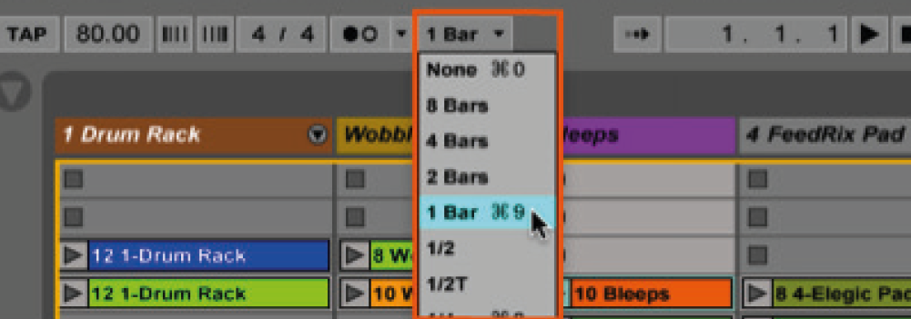

Live’s ‘Quantization Menu’

**Scene Launch**

Pressing the Scene Launch buttons on the right side of the Launchpad will trigger horizontal rows of clips, aka ‘scenes’. These buttons allow you to launch, stop, and/or record multiple clips with one button, and are fantastic for performance. Just like the 8x8 grid of pads, the Scene Launch buttons match the scene colors on your Live screen.

If you have more than 8 tracks the Scene Launch buttons will launch the whole scene, not just the eight clips you can see on the pads.

**Workflow Tip:** While everyone uses Live differently, scenes are often used to break up music into different sections. For example, you could trigger the verse, chorus and bridge of your song with just three Scene Launch buttons.

**Session Navigation**

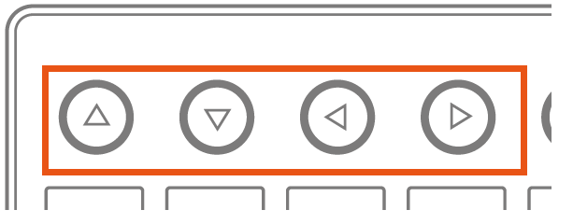

The simplest way to navigate the Session View is with the Navigation Arrows, located at the top-left of the Launchpad as one might expect, the Up and Down arrow buttons move the Launchpad’s 8x8-pad coverage up or down the Session View in 1-Scene increments. The Right and Left arrow buttons move pad coverage left or right, one track at a time. When you have gone as far as possible in a given direction the corresponding button will turn off. With live performance in mind, you may have wondered how to quickly navigate hundreds, or even thousands of clips. To move around your Session View in big chunks, please refer to **Zoom** mode.

To exit this mode just press any other Mode button.

**Zoom mode**

To enter this mode press and hold the session button.

This mode is useful when you have a huge set with many scenes and tracks on it. This mode is not useful if you don't have more than 8 scenes and/or more than 8 tracks. In this mode you are able to navigate through the session by selecting 8 scenes or tracks at one time. This could be done using the navigation keys or just pressing the grid pads. You will now see solid red pads indicating 8x8 areas containing clips. (If an 8x8 area does not have at least one clip the pad will be unlit). Simply press one of these red pads, or use the Up/Down arrow buttons, to jump the Session View’s focus in 8x8 blocks. If you jump into an 8x8 area where no clips are playing, areas with playing clips will be represented by solid green pads. Note that you will see as much rows as scenes/8 you have. And as much columns as much tracks/8 you have.

In the zoom mode, the color coding is a little different: **AMBER**: Indicates the currently selected block of clips, which will be surrounded by the ‘ring’ in the software. **GREEN**: There are clips playing in that block of clips (though that may not be the block of clips selected). **RED**: There are no clips playing in that range. **NO COLOR**: There are no tracks or scenes in that range.

To exit this mode release the session button (you will enter/return to session mode).